**Vehicle Suspension Systems: Structure, Types, and Applications with Focus on MacPherson Strut**

Vehicle suspension systems are essential parts that have a big impact on a car's handling, overall performance, and ride comfort. By absorbing impacts from irregularities in the road and preserving the best possible tire contact with the ground, they operate as the vital interface between the vehicle body and the road surface. The MacPherson strut suspension system, one of the most popular systems in the current automotive industry, is the focus of this report's analysis of the numerous suspension types seen in contemporary automobiles. The MacPherson strut is the recommended option for many passenger cars globally because it provides a sophisticated combination of performance, affordability, and space efficiency. This paper offers insights into the engineering aspects behind suspension system selection and design by examining its structure, components, operating principles, and real-world applications.

**Overview of Vehicle Suspension Types**

Different suspension architectures are used by automotive engineers; each is made to satisfy performance standards, production limitations, and vehicle attributes. Gaining knowledge of these various suspension systems helps one better understand the engineering choices that influence the design of contemporary vehicles.

Double Wishbone Suspension

With independent suspension systems, each wheel on the same axle can move vertically without influencing the other wheel, improving handling and ride comfort. Beyond the MacPherson strut, this category contains a number of unique designs, such as the double wishbone (or double A-arm) suspension, which employs two control arms per wheel to deliver precise wheel control and superior handling qualities. Although more expensive and complex, multi-link suspension is another advanced independent system that uses many independent arms to regulate wheel movement with highly adjustable properties.

Wheels on the same axle are connected by non-independent suspension systems, allowing one wheel's movement to directly impact the other. The solid or beam axle, which joins opposing wheels with a sturdy beam, is the most prevalent example. These designs are ideal for trucks and off-road vehicles due to their exceptional endurance and load-carrying capabilities, even though they provide a less sophisticated riding experience than independent systems. A straightforward beam that twists to generate spring action while keeping a comparatively small size is used in torsion beam suspensions, which are a compromise between independent and non-independent systems.

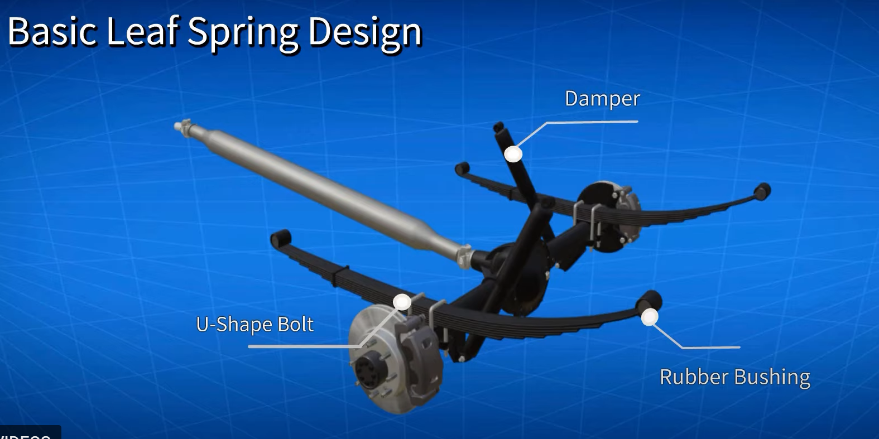

Leaf spring suspension systems, among the oldest suspension technologies still in use, consist of several layers of metal springs bound together to absorb road shocks. Despite their traditional design, leaf springs remain common in trucks and heavy-duty vehicles due to their excellent load-bearing capacity and durability. The relative simplicity of these systems also translates to lower manufacturing and maintenance costs in applicable vehicle types.

Air suspension systems replace conventional steel springs with air-filled bellows that can be inflated or deflated to adjust ride height and stiffness. These systems offer superior ride comfort and the ability to maintain a level vehicle regardless of load. While primarily found in luxury vehicles and high-end SUVs, air suspension technology has expanded to other vehicle segments as manufacturing costs have decreased.

Advanced suspension technologies include semi-active and active systems that use electronic controls to modify suspension behavior in real-time. Semi-active systems employ electronically controlled dampers that can adjust damping characteristics based on road conditions and driving style. Active suspension systems go further by incorporating actuators that can exert force on the suspension, actively counteracting body roll and pitch during cornering and braking. These sophisticated systems offer significant performance advantages but add cost and complexity.

Emerging technologies include regenerative suspension systems that can harvest energy from suspension movement, potentially contributing to vehicle efficiency and reduced emissions in electric vehicles. This represents an innovative approach where suspension systems evolve from purely mechanical components to integrated elements of the vehicle's energy management strategy.

**MacPherson Strut Suspension: Structure and Components**

One of the most popular suspension designs in contemporary passenger cars is the MacPherson strut suspension, which was created by American engineer Earl MacPherson in the 1940s. It stands for a certain kind of independent suspension that provides a good trade-off between cost, performance, and spatial efficiency.   
The MacPherson strut suspension's ability to combine several uses into a single, small assembly is its distinguishing feature. The fundamental component of the system is a strut assembly, which essentially combines the functions of an upper control arm and a shock absorber into a single element. Compared to alternative separate suspension designs, this integration lowers the total number of components, which makes the system easier to manufacture and uses less space.

The strut assembly represents the most distinctive component of this suspension type. It combines a shock absorber and coil spring into a single structural unit that also serves as a primary load-bearing member of the suspension. This component "remains responsible for enduring the weight of the car along with the road impacts" while simultaneously controlling suspension movement. The shock absorber portion of the strut uses hydraulic fluid to dissipate energy from road inputs, converting it to heat and thereby preventing excessive oscillation of the suspension.

Another essential part of the MacPherson strut suspension is the lower control arm, sometimes known as the wishbone or A-arm. This part helps regulate the wheel's assembly motion during suspension travel and connects the steering knuckle to the vehicle's body. The MacPherson design only needs a lower control arm, as the strut itself serves as the upper control arm, in contrast to double wishbone systems that use both upper and lower control arms. This streamlined configuration helps the system use less space and have fewer parts.

The steering knuckle serves as a crucial connecting element within the MacPherson system. This component "links the strut assembly of the vehicle to the wheel hub, allowing smooth steering movement". The design of the steering knuckle accommodates both the vertical motion of the suspension, and the rotational movement required for steering, making it a complex component with significant influence on the suspension's overall performance characteristics.

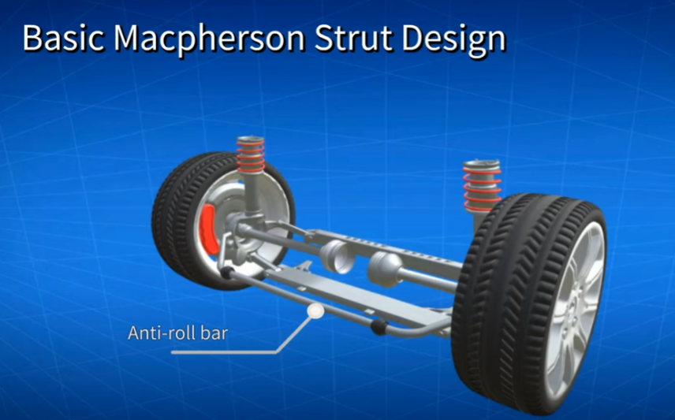

Many MacPherson strut suspensions also incorporate a sway bar, also known as an anti-roll bar. This component "reduces the body roll during the cornering of the vehicle" by connecting the suspension components on opposite sides of the vehicle. When the vehicle corners, the sway bar resists the tendency of the body to roll outward, improving handling stability and driver confidence during directional changes.

Additional components in the MacPherson system include various rubber bushings, ball joints, and the upper strut mount with strut bearing. The ball joints of the lower control arms and the strut bearing of the upper strut mount work together to facilitate wheel turning during steering operations. These components serve to isolate vibrations, allow for necessary articulation, and provide mounting points for the suspension while contributing to the system's overall functionality.

**Working Principles of MacPherson Strut Suspension**

The MacPherson strut suspension operates through a relatively straightforward mechanical principle that effectively manages the competing demands of ride comfort and handling performance. Understanding its working mechanism provides insight into why this system has become so widely adopted across the automotive industry.

The ability of the MacPherson strut suspension to absorb road shocks while preserving wheel alignment is its primary function. The wheel of a car with this suspension travels vertically in relation to the vehicle body when it hits an uneven patch of road. To absorb this motion and store the impact energy, the coil spring in the strut assembly compresses or extends. Technical sources state that a coil spring and a damper make up the basic construction method of this kind of suspension system. On rough terrain, this spring stays connected to the system to effectively absorb shocks from any abrupt jerks.

Following the initial compression of the spring, the damper component of the strut plays a critical role in controlling the subsequent motion. As technical documentation explains, "After this, the shock absorber utilises hydraulic fluid to release the heat created by this shock energy". This damping action prevents the spring from oscillating excessively, which would result in a bouncy, uncomfortable ride. The conversion of kinetic energy into heat through the damper represents a key function that distinguishes a well-designed suspension from a simple spring system.

During suspension movement, the lower control arm pivots around its mounting points on the vehicle chassis, allowing the wheel to move vertically while maintaining proper alignment. The ball joint connection between the control arm and steering knuckle permits the required articulation while transferring loads between components. This arrangement allows the suspension to absorb impacts while keeping the tire properly positioned on the road surface for optimal traction and handling.

In steering operations, the MacPherson strut design offers particular advantages. The strut itself rotates within its upper mount, eliminating the need for an upper control arm with additional pivot points. As described in engineering documentation, "The ball joints of the lower control arms and the strut bearing of the upper strut mount work together to turn the wheels. This motion is made possible by the steering mechanism, which is linked via a tie rod with a steering knuckle". This integration of suspension and steering functions contributes to the system's space efficiency and reduced component count.

By preventing body roll, the sway bar is activated when a car with MacPherson struts corners. The sway bar twists when the car leans toward the outside of the turn, producing resistance that lessens the amount of body roll. By keeping the tires in more constant touch with the road, this enhances handling.   
As technical literature states: "Any undesirable movements of the car caused by improper road conditions get efficiently restrained when both these components function well in sync in this form of suspension," the MacPherson strut suspension's effectiveness stems from the synchronized operation of all these components. The balance between control and comfort provided by this coordinated functioning is what has led to the system's widespread use in contemporary passenger cars.

**Advantages and Limitations of MacPherson Strut Suspension**

The widespread adoption of MacPherson strut suspension stems from several distinct advantages it offers over alternative designs. However, like any engineering solution, this system also presents certain limitations that engineers must consider during vehicle development.

Among the primary advantages of MacPherson strut suspension is its simplicity and component efficiency. According to automotive engineering sources, "When compared to other suspension systems, this system consists of fewer components, resulting in easy maintenance and manufacturing". The integration of multiple functions into the strut assembly reduces the overall part count, simplifying assembly processes and potentially improving reliability through fewer potential failure points. This simplified design translates directly to manufacturing advantages in high-volume production environments.

The economic benefits of MacPherson strut suspension represent another significant advantage. As the design of this suspension system is simple, the production and repair costs are also comparatively lower. This cost-effectiveness makes the system particularly attractive for mass-market vehicles where manufacturing economics significantly influence design decisions. The reduced complexity also typically translates to lower maintenance costs over the vehicle's lifetime, benefiting both manufacturers and consumers.

Space efficiency stands as a defining advantage of the MacPherson design. The compact vertical packaging of the strut assembly frees up lateral space in the engine compartment, which has become increasingly valuable as modern vehicles incorporate more systems into limited space. This spatial efficiency has contributed significantly to the system's popularity in front-wheel-drive vehicles with transverse engine layouts.

Despite these advantages, MacPherson strut suspension also presents several limitations that engineers must address. One significant constraint involves the system's geometric characteristics during wheel travel. Technical sources identify that "this suspension system does not allow vertical wheel movement without a certain degree of change in the camber angle or sideways movement". This characteristic can adversely affect tire wear and handling precision, particularly in performance-oriented applications where consistent wheel alignment throughout suspension travel becomes more critical.

The structural requirements of MacPherson strut suspension present another potential limitation. Engineering documentation notes that "The MacPherson strut suspension system requires a very strong top mount along with an enhanced vertical space". This requirement can influence vehicle design and may necessitate reinforcement of the strut tower area, potentially adding weight or complexity to the vehicle structure. The load paths through the body structure must be carefully engineered to support the forces transmitted through the strut's upper mounting point.

Handling characteristics represent another area where MacPherson strut suspension may face limitations. According to technical assessments, "This sort of suspension affects the handling of the vehicle to a certain extent, offering a minimal opportunity for camber change or choosing the roll centre". These geometric constraints can make it challenging to optimize the suspension for both ride comfort and handling precision, particularly in performance-oriented applications where more sophisticated suspension geometries might offer advantages.

Noise and vibration transmission can also present challenges with MacPherson strut designs. Industry sources observe that "MacPherson strut suspension systems in cars tend to produce more vibration and noise than other forms of suspension systems". This characteristic requires careful attention to isolation strategies and damping materials to maintain acceptable noise, vibration, and harshness (NVH) performance in modern vehicles with increasingly demanding comfort expectations.

**Practical Applications of MacPherson Strut Suspension**

The MacPherson strut suspension has found widespread application across various vehicle categories due to its balanced combination of performance, cost, and packaging efficiency. Its predominant use in modern passenger vehicles represents a testament to its practical advantages in real-world automotive applications.

MacPherson strut suspension is most commonly used in front-wheel-drive cars. Technical sources state that "it is the most widely used suspension system for passenger car front axles." The system's suitability for transverse engine layouts, where space efficiency surrounding the powertrain becomes especially important, accounts for its widespread use. The engine, transmission, and related parts can fit in the restricted space available in front-wheel-drive systems because to the MacPherson strut's small design, which also enables engineers to optimize interior space.

Another important market for MacPherson strut suspension is compact and subcompact automobiles. The system's "typically small footprint, allowing effective space usage... makes it ideal for small and compact vehicles," according to engineering literature. The MacPherson design's space-efficient nature offers significant packaging benefits in smaller vehicle classes where every millimeter of passenger and cargo space must be maximized. Furthermore, the system's cost-effectiveness fits in nicely with the financial limitations of cars in these market niches.

While less common, rear-axle applications of MacPherson strut suspension also exist in the automotive market. Technical sources mention that "Less frequently, the MacPherson strut modification is used on the rear axle of a car". When employed in rear suspension applications, the system often incorporates design modifications to accommodate the different functional requirements of rear wheels, which typically do not require steering capability. According to engineering documentation, "The rear MacPherson strut suspension often features three suspension arms" to provide the necessary wheel location and load management.

Economy-focused mid-size sedans and crossovers frequently employ MacPherson strut suspension, particularly in non-premium market segments. The system's cost-effectiveness and adequate performance characteristics make it well-suited to vehicles where value represents a key purchasing consideration. The simplified maintenance requirements of MacPherson strut suspension also align well with the ownership expectations in these vehicle categories.

The MacPherson strut suspension's use has expanded into more upscale car classes due to its compatibility with a variety of electronic improvement systems. Adaptive damping technologies that may "effectively adjust the damping characteristics considering the driving circumstances" are frequently used in modern implementations. These developments expand the application range of the fundamental MacPherson architecture to encompass vehicles with more stringent performance requirements by enabling performance capabilities that would not have been achievable with simply passive systems.

**Recent Advancements in Suspension Technology**

Although MacPherson strut suspension's fundamental design hasn't changed since it was first introduced, major technical developments have improved its performance and solved some of its inherent drawbacks. These developments are the result of continuous technical efforts to enhance the efficiency, comfort, and dynamics of vehicles.   
MacPherson strut suspension systems' performance possibilities have been transformed by adaptive damping technology. According to industry insiders, "These sophisticated forms, whether they are electronic or magnetorheologically controlled dampers, are rapidly gaining popularity." Taking into account the driving conditions, they are able to efficiently modify the damping characteristics. These systems have the ability to change damping rates in real time, offering gentler settings for comfort when driving normally and quickly transitioning to stronger settings when aggressive maneuvers or bad road conditions are encountered.

Magnetorheological (MR) dampers represent a particularly innovative advancement in suspension technology. Research indicates that such dampers use magnetic fields to instantly change the viscosity of magnetorheological fluid, allowing for rapid adjustments to damping characteristics without mechanical valves. This technology offers significant advantages in response time and control precision compared to conventional hydraulic damping systems, potentially enhancing both ride quality and handling performance in vehicles equipped with MacPherson strut suspension.

Without changing the core concept, MacPherson strut performance has been greatly enhanced by lightweight materials and sophisticated manufacturing processes. According to technical literature, "The advanced inventive designs contribute to improved vehicle efficiency and improved range which effectively lowers the weight of suspension without compromising on the performance" . In order to decrease unsprung mass and enhance handling accuracy and ride quality, contemporary MacPherson strut designs have included materials like carbon fiber, high-strength steel, and aluminum.

Semi-active suspension systems have emerged as a more practical and cost-effective alternative to fully active systems. According to research, these systems focus on "devices that control the suspension damping" to improve vehicle dynamics. By modulating damping forces rather than generating counteracting forces, semi-active systems achieve many of the benefits of active suspension with lower energy requirements and system complexity, making them increasingly common in mid-range and premium vehicles equipped with MacPherson strut suspension.

**Conclusion**

The intricate engineering factors that affect car suspension design are revealed by examining vehicle suspension systems, with an emphasis on the MacPherson strut design. Because it effectively balances performance, affordability, and packaging efficiency, the MacPherson strut has become one of the most popular suspension systems available to engineers.   
The ongoing popularity of the MacPherson strut suspension can be attributed to its basic design advantages. It provides sufficient performance for the majority of passenger car applications while reducing the number of components and streamlining manufacturing by the integration of several functions into a single strut assembly. Modern car designs with transverse powertrains and increasingly congested engine compartments have benefited greatly from its spatial efficiency.

While the MacPherson strut suspension presents certain inherent limitations, particularly in terms of its geometric characteristics during suspension travel, ongoing technological advancements have addressed many of these challenges. Innovations in electronic damping control, lightweight materials, and integrated system approaches have significantly enhanced the capabilities of modern MacPherson strut implementations beyond what was possible with the original design.

MacPherson strut suspension is used in a variety of vehicle types, including crossovers, family sedans, and small economy automobiles. This adaptability emphasizes how sound the system is as an engineering solution for the suspension requirements of regular passenger cars. The MacPherson strut's balanced approach to the conflicting goals of comfort, handling, manufacturing cost, and packaging efficiency explains its continued prevalence in the car industry, even though alternative designs may offer advantages in particular performance parameters.

Additional innovation in suspension systems, such as the MacPherson strut, is anticipated as vehicle technology advances toward electrification, autonomy, and greater connectivity. While integration with modern control systems will allow for more adaptable reactions to driving circumstances, emerging technologies like regenerative suspension and better materials promise to improve performance and efficiency. These changes imply that although the MacPherson strut's basic ideas might not change, its application will go further to satisfy the evolving needs of contemporary mobility.